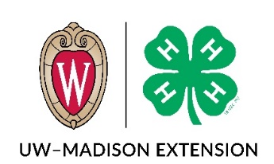

MEMBER’S APPLICATION FOR COUNTY 4-H AWARDS

Name Club _________

Circle One (Grade in previous school year): Jr. (3-5) Inter. (6-8) Sr. (9+)

To be completed by the member with his/her record book - Place in inside front cover pocket.

On lines 1-3 please list the 3 projects that are being submitted for scoring and record book placement. For the projects on the lines marked “D” you will receive a disk only. (Cultural Arts, Dairy, Foods & Nutrition, Shooting Sports, Etc.)
1. 2. 3.
D D D
D D D
Choose here if you need a new plaque:
_____ I need a new plaque; my current plaque is full. From 2021 forward, all plaques will be white.
_____ I am applying for an OVERALL RECORD BOOK AWARD. This award is calculated using projects on lines 1-3 above. For completing a successful record book, you will receive an annual disc with the year.
Description of Record Book Program Updates:
- Each member is asked to report on three projects. These projects will be scored. You may submit more project forms than is required, the extra projects will be rewarded with a project disk.
- Activity Summaries are required. There will be three for all members. Your age will be taken into consideration when scoring these. There are more options to display your learning from our events.
- Hour Tracker: Will be part of each project that you submit. Some projects will have a project completion certificate that you can use in place of the hour tracker.
- There will be a new award for 3rd—8th grade members. A 4-H “Savings Account” will be established for each successful record book.

________________________________ _______________________________
Member Signature Parent/Guardian Signature

4-H/Awards/Record Books/2021/Record Book Application_2021

