*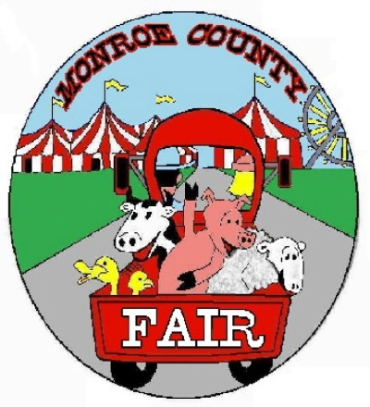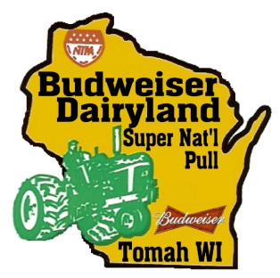MONROE COUNTY AGRICULTURAL SOCIETY*

P.O. BOX 908 – Tomah, WI 54660

Phone: 608-372-2081 Fax: 608-372-1052

Email: [mail@tomahtractorpull.com](mailto:mail@tomahtractorpull.com)

[*www.tomahtractorpull.com*](http://www.tomahtractorpull.com)[*www.monroecountyfairwi.com*](http://www.monroecountyfairwi.com)

***Promoters of the Monroe County Fair and the***

***June 22nd – 24th, 2023 Budweiser Dairyland Super National Truck & Tractor Pull July 26th – 30th, 2023***C:\Program Files (x86)\Microsoft Office\MEDIA\OFFICE12\Lines\j0115855.gif

***2023 Fair Schedule***

Tuesday July 25th

11:00 am – 9 pm Gates open to allow Animals to arrive.

3:00 – 9pm Weigh – Ins

3pm – 5pm Beef

5pm – 7pm Sheep & Goats

7pm-9pm Swine

6:00pm Beef must be in place and weighted.

10:00pm Sheep, Goats & Swine must be in place and weighted.

Wednesday July 26th

8am – 10:30 am Gates open to allow animals in, ALL Animals must be in place by 10:30am.

12:00/noon Fair officially OPENS to the public!

1:00 pm Llama Show – Upper Show Ring

3pm – 7 pm White Exhibit Hall Entry Times

4:00 pm Swine Show - Lower Show Ring

5:00 pm Dog Obedience, Showmanship and Rally Shows – 4:30 Check in- Ice Center Showring

Thursday July 27th

8am – 11 am White Exhibit Hall Entry Times. ALL exhibits need to be in place by 11:00am.

9:00 am Beef Show – Upper Show Ring

10:00 am Rabbit Show – Lower Show Ring

4:00 pm Sheep Show – Upper Show Ring

Friday July 28th

9:00 am Dairy Show – Upper Show Ring

10:00 am Poultry Show – Lower Show Ring

5:00 pm Goat Show – Lower Show Ring

Saturday July 29th

9:00 am Overall Showman Round Robin Selection Location – Upper Show Ring

(Dairy – Beef – Sheep – Swine – Goats – Llama)

1:00 pm Monroe County all Abilities Show – Lower Show Ring

Sunday July 30th

9:00 am Dog Agility – Horse Arena on the fairgrounds

4:30 pm All exhibits released.