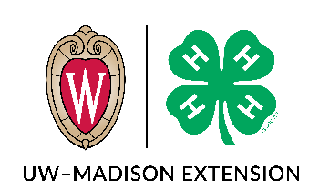
MEMBER’S APPLICATION FOR RECORD BOOK AWARDS

To be completed by the member with their record book.
Place this inside left front cover pocket of record book.
Name Club

Circle One (Grade in previous school year): Jr. (3-5) Inter. (6-8) Sr. (9+)

Please list the 3 PROJECTS that are being submitted for scoring and record book placement. (Minimum of 1 for Jr., 2 for Inter., and 3 for Sr.)

1. ______________________ 2. ______________________ 3. ______________________

ACTIVITY DISKS will be awarded to those who participated in County events such as Festival of Arts, Clothing Revue, Foods Preview, Camp, etc.

Choose here if you need a new plaque:
_____ I need a new plaque, my current plaque is full.
_____ I am applying for an OVERALL RECORD BOOK AWARD. This award is calculated using the
projects and activities listed above.

NEW THIS YEAR:

“My 4-H Story” is an essay type question that should include the following:
- Introduce yourself; age, interests/hobbies, family (parents, guardians, brothers & sisters), where you live and go to school, when and why you joined 4-H.
- Tell about your project area. Include things such as: How has 4-H helped you learn things about your project you didn’t know before? How has your project grown in size and scope? What new techniques have you tried? Were they successful or unsuccessful? Explain.
- Highlight other 4-H projects and activities. What were some of your major learning experiences and special interests? Did you encounter unusual situations? If so, explain.
- Tell about 4-H growth. Explain how 4-H has helped you become a better leader and citizen. How has 4-H increased your interest and participation in your community? What have you learned from team efforts?
- Minimum four paragraphs (8 sentences), maximum 1 page, two-sided.

__________________________________ ________________________________
Member Signature Parent/Guardian Signature

